**BDAT 1000 – 04 Data Manipulation Techniques Name: Shubham Chawla**

***Midterm-Exam* Student Number: 200493036**

* **Creating Database MidtermExam**

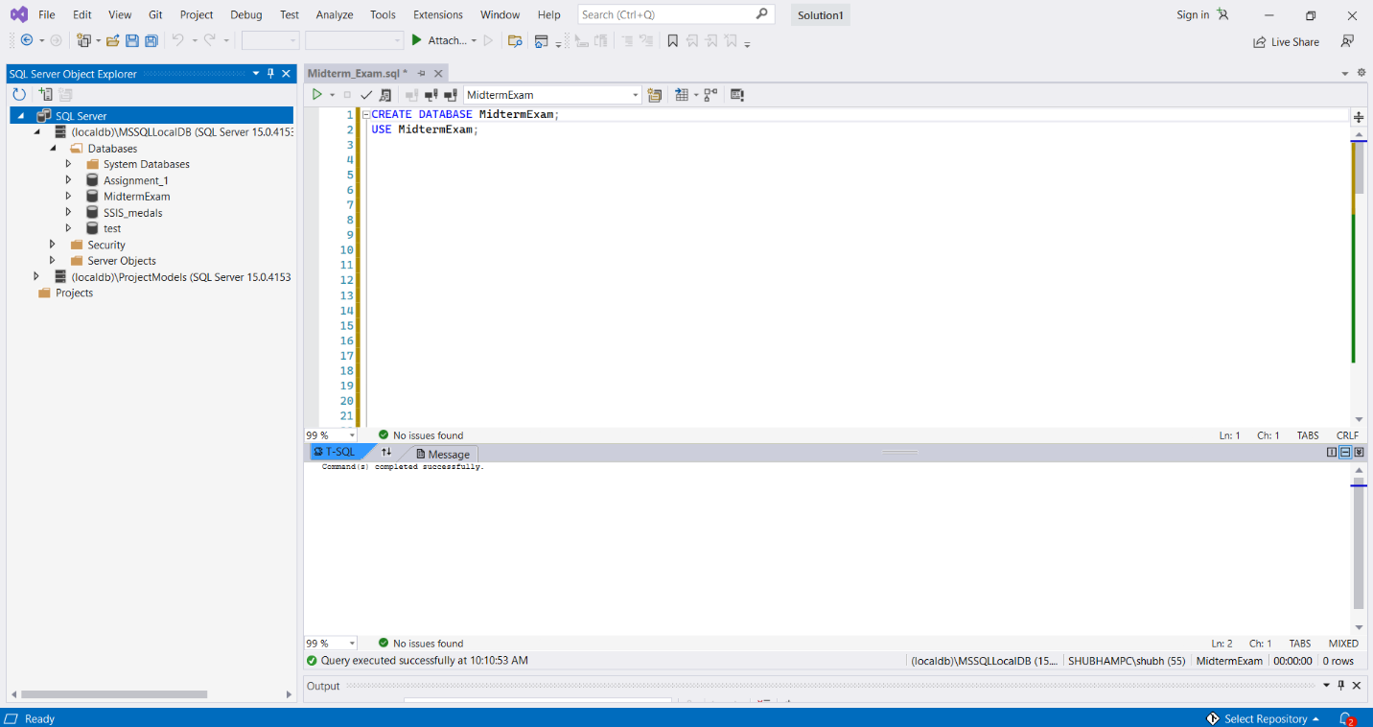

* **Creating Products table and Inserting Values into the Products table**

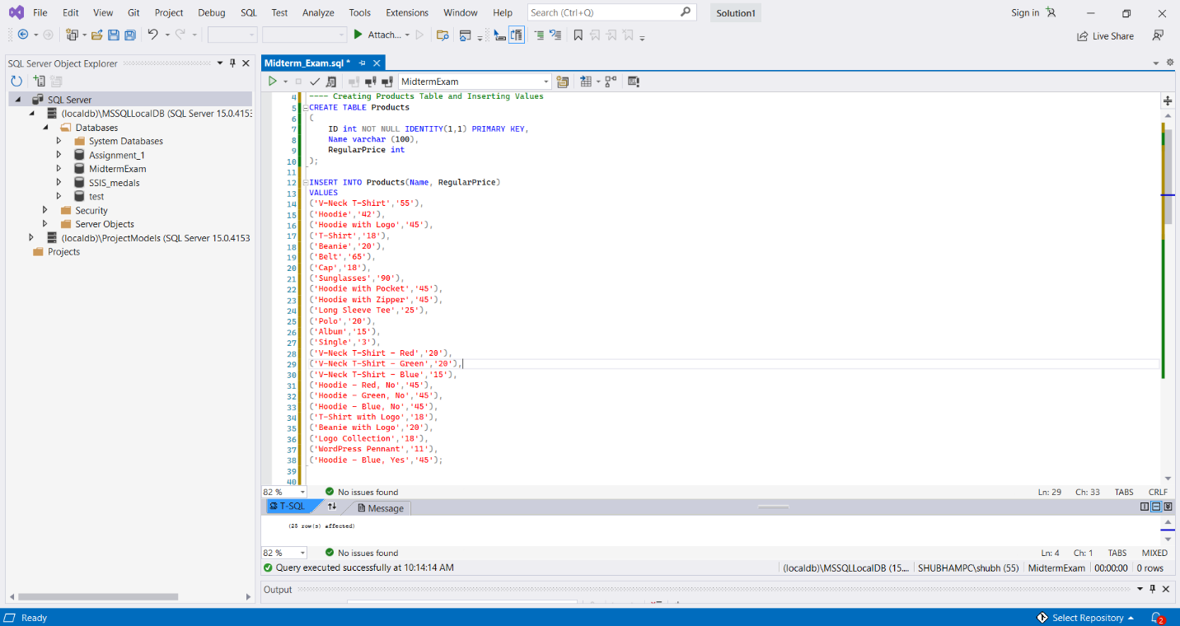

* **Creating Customers table and Inserting Values into the Customers table**

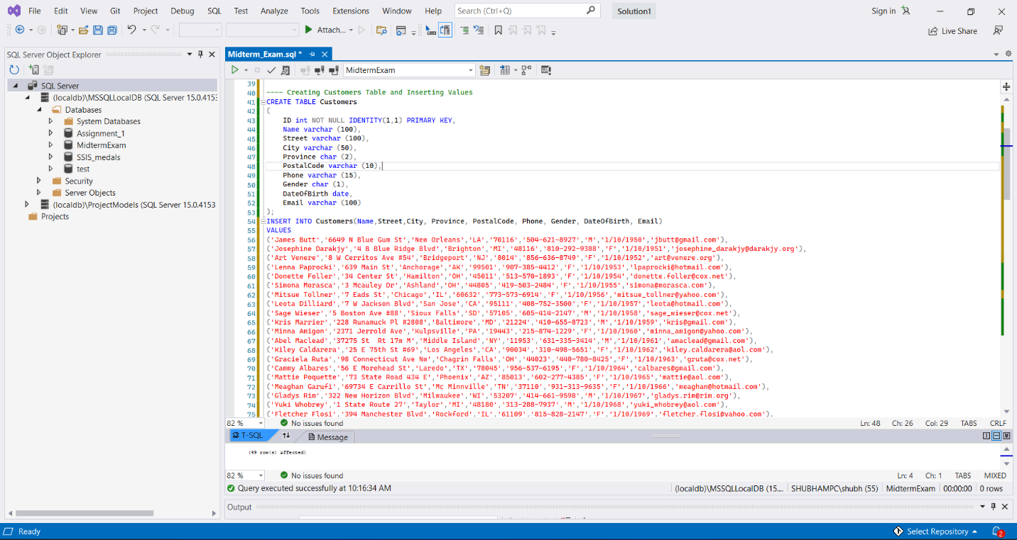

* **Creating Orders table and Inserting Values into the Orders table**

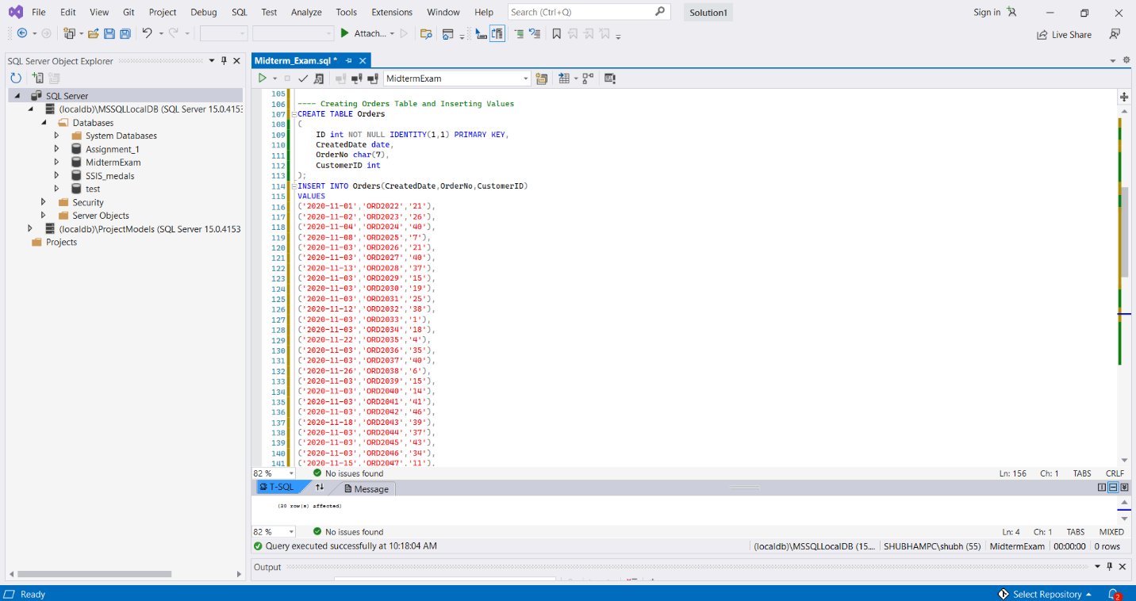

* **Creating OrderItems table and Inserting Values into the OrderItems table**

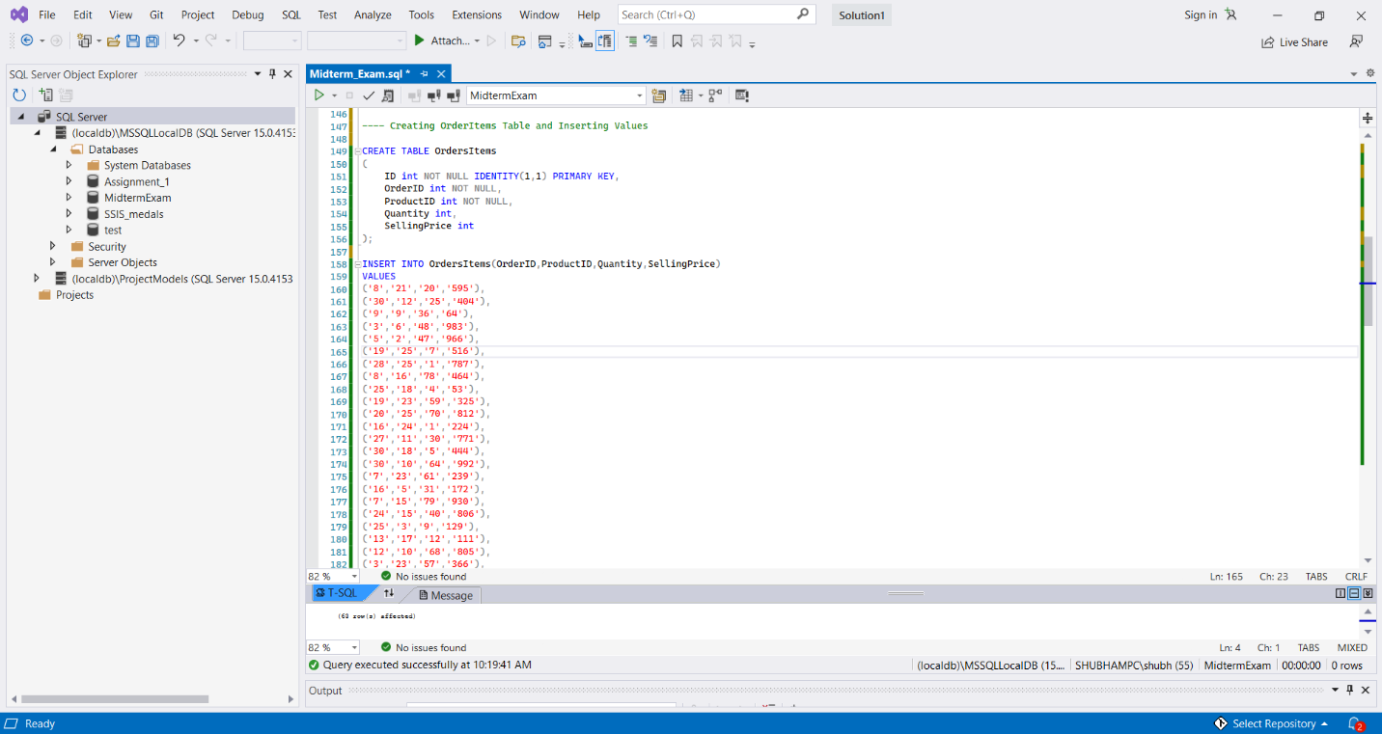

**Question 1-4**

1. ***Display total count of Products***
2. ***Display total count of Orders***
3. ***Display total count of Customers***
4. ***Display total count of OrderItems***

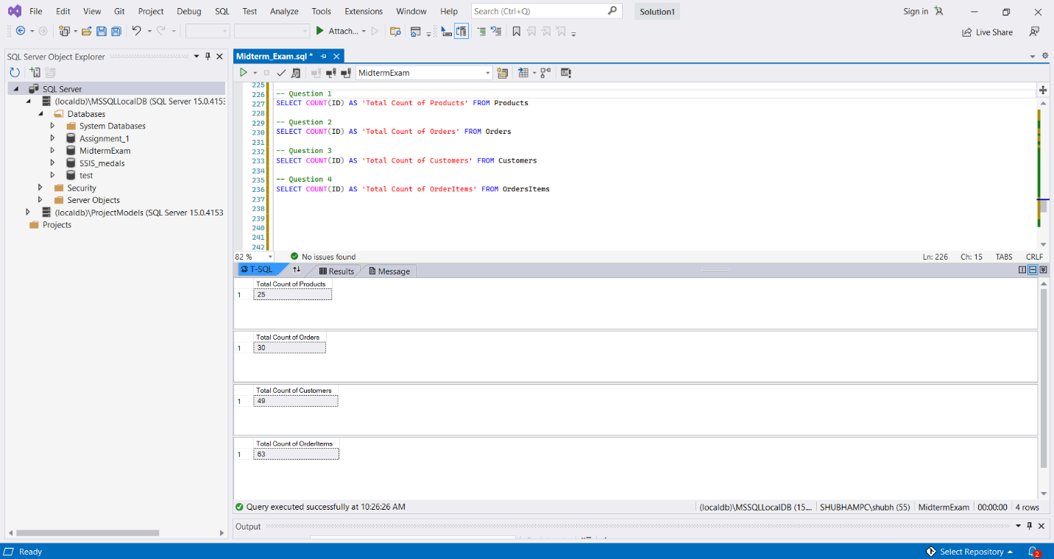

**Question 5 Display customer name with atleast one order** **(Output: 25 Records)**

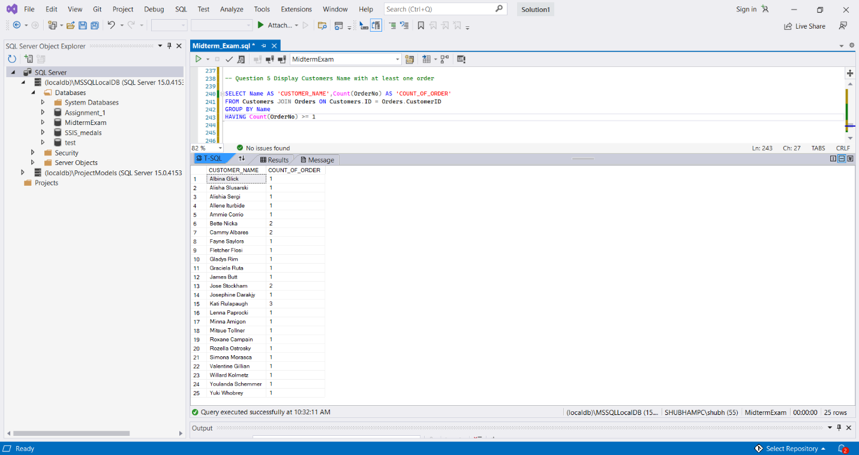

**Question 6 Display product names which sold for more than $500 (Output: 30 Records)**

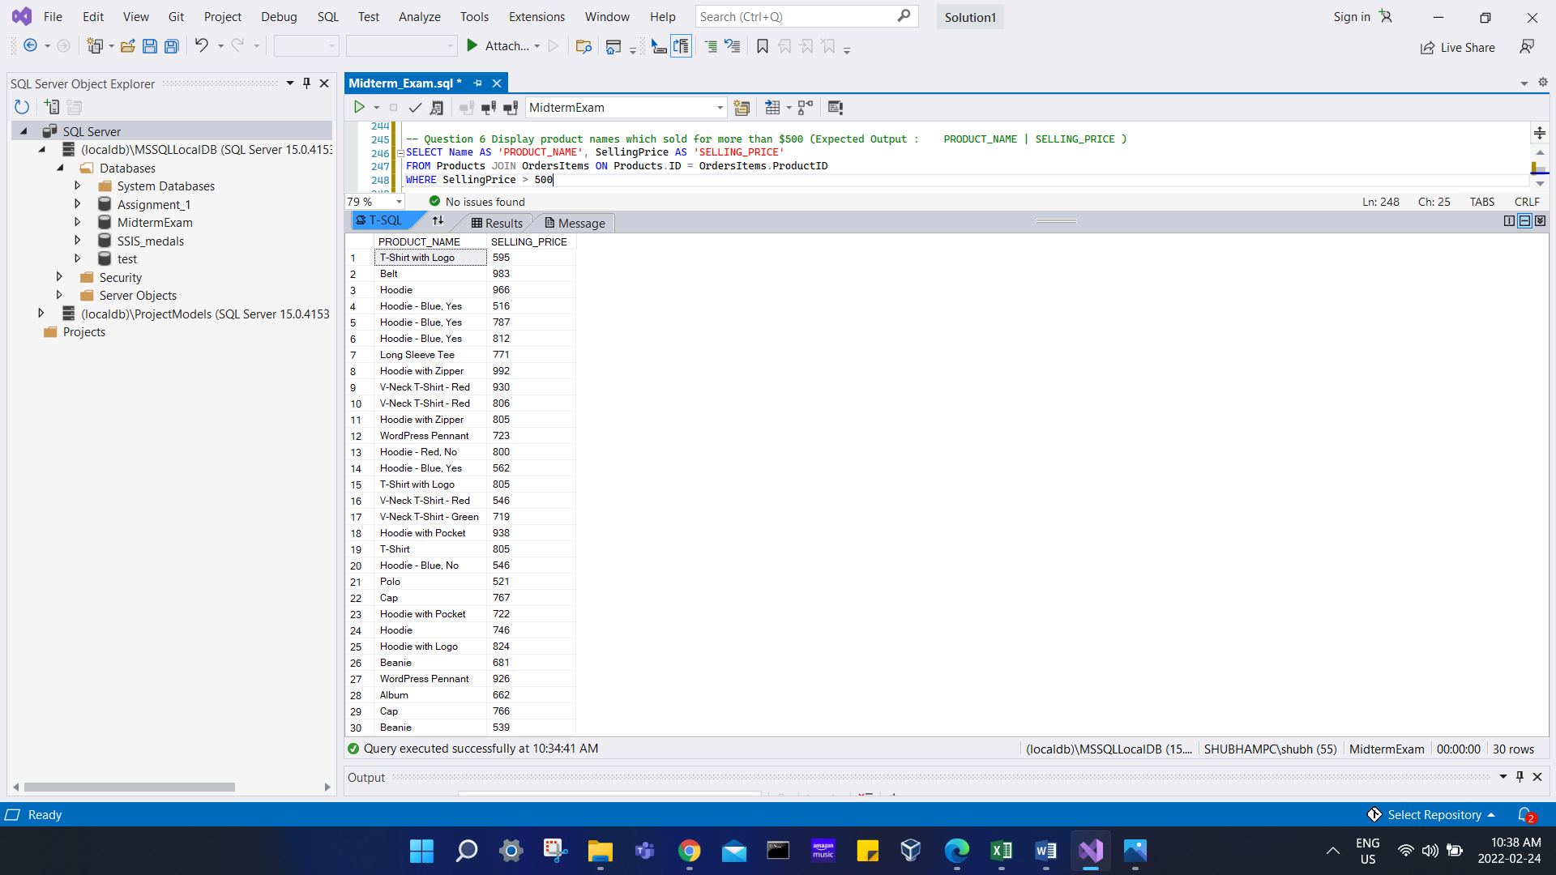

**Question 7 Display customer names where NAME contains the letters 'am'**

**(Output: 6 Records)**

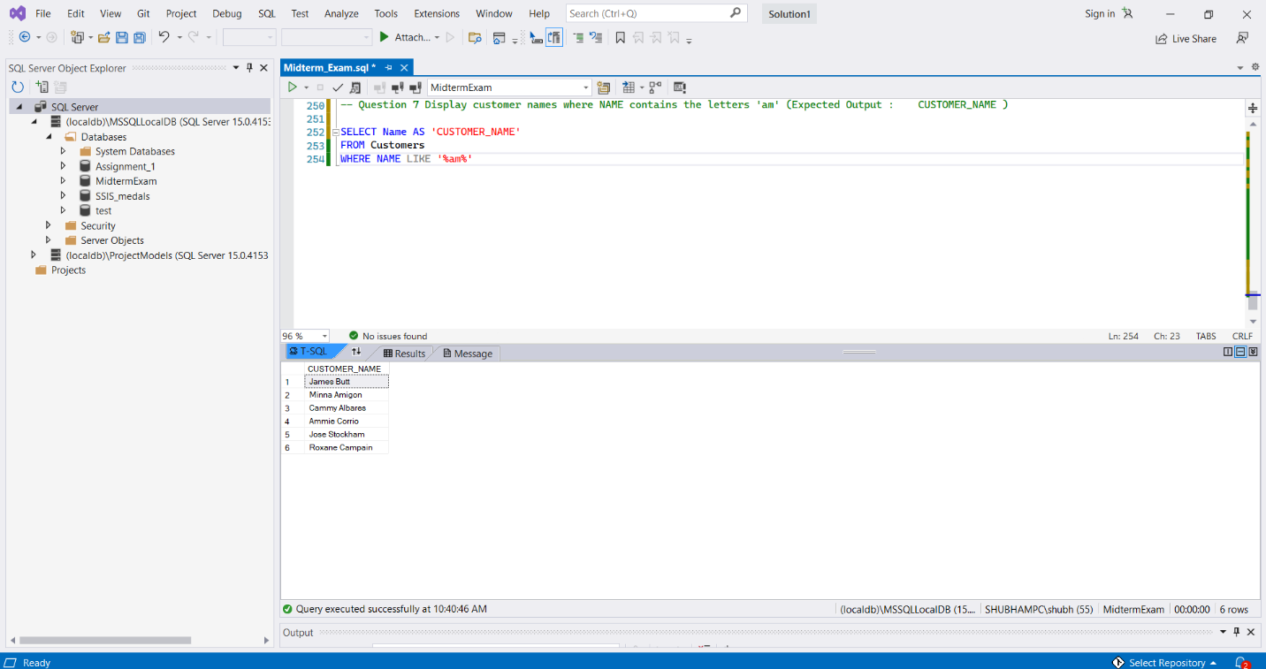

**GITHUB Link to all files:** [**https://github.com/shubhamchawla02/BDAT-1000-04-Midterm**](https://github.com/shubhamchawla02/BDAT-1000-04-Midterm)